|  |  |  |  |  |  |
| --- | --- | --- | --- | --- | --- |
| Date | 1-Dec-22 | | | Tester Name | Janette Paus |
| Environment | Penfax - Test 2 | | | Login used |  |
| Operating System | Windows | Version: 21H2 | Update Number: | | |
| Software Used | Select Software | Version: 107.0.1418.56 | Update Number: | | |
| Select Software | Version: | Update Number: | | |
| Application Release version | R22.4.1 | | | | |
| Test Case Title | E 20.02 | | | | |
| Test Type | Regression | | | | |
| Test Scenario | Reverse an Enrolment | | | | |
| Expected Results | The member no longer has an active employment period & the investment account is deleted & no member profile. (Unable to delete member profile itself – not required by business). | | | | |
| Pass/Fail | Pass | | | JIRA# |  |

To find a member for this, it’s best to use a recent enrolment as that would be a more common occurrence.

*Note: Anything business needs to reverse from a while back, they would add a term date (not reverse the enrolment).*

Go to Batches 🡪 Data Posting Batches

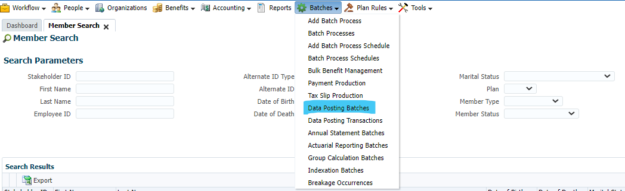

Search Plan = PEPP; Batch Type = Enrolment; Batch Status = Closed

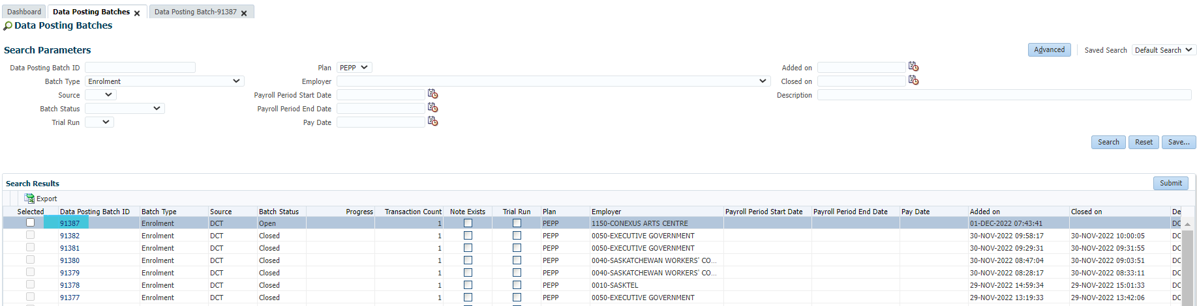

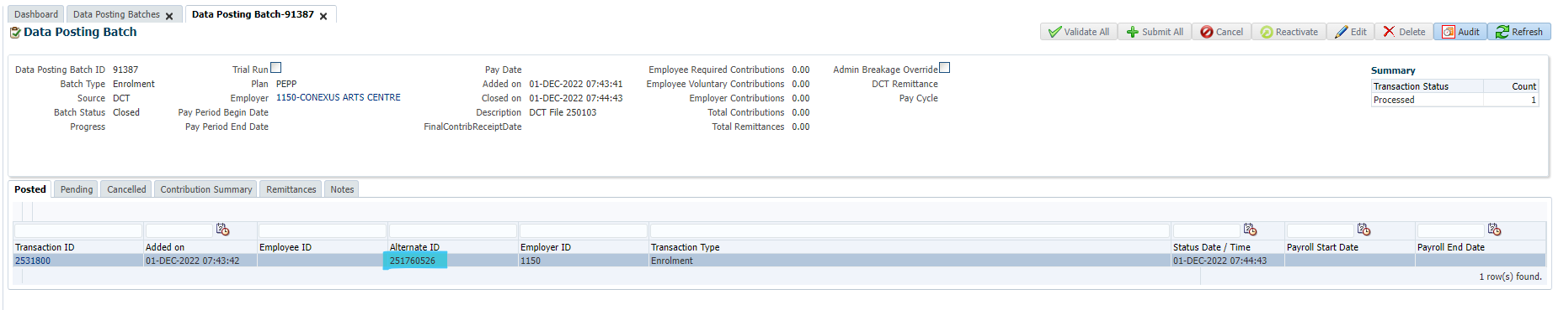

Click Investments to ensure there is no money in the investment account:

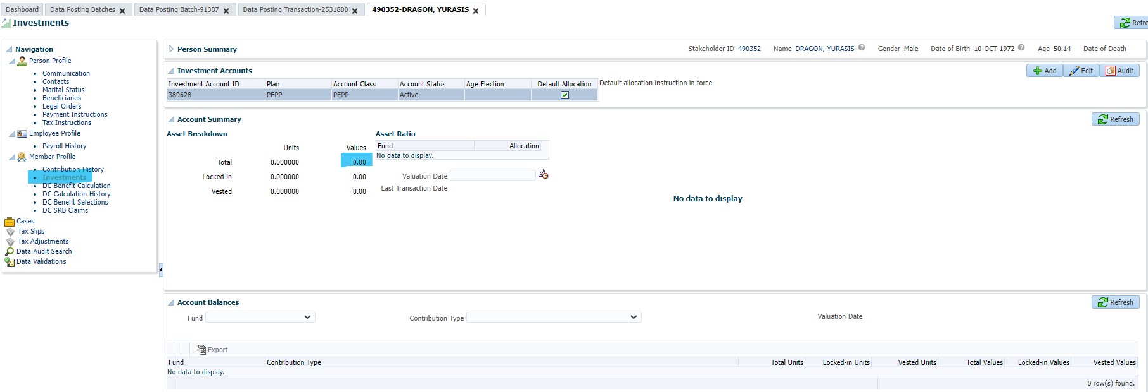

Go to employee profile, delete the departments, scope code and employment period (in that order)

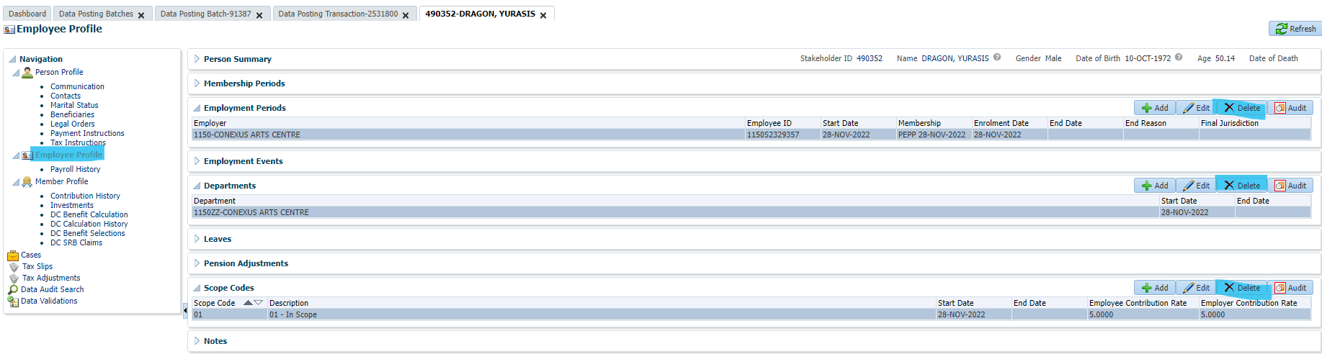

The Employee Profile has disappeared:

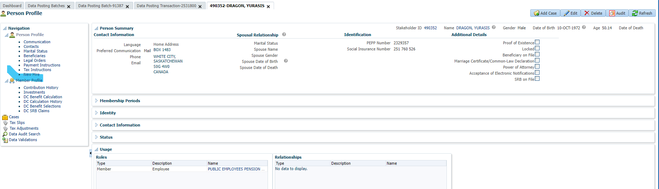

Go to Member Profile and click Delete:

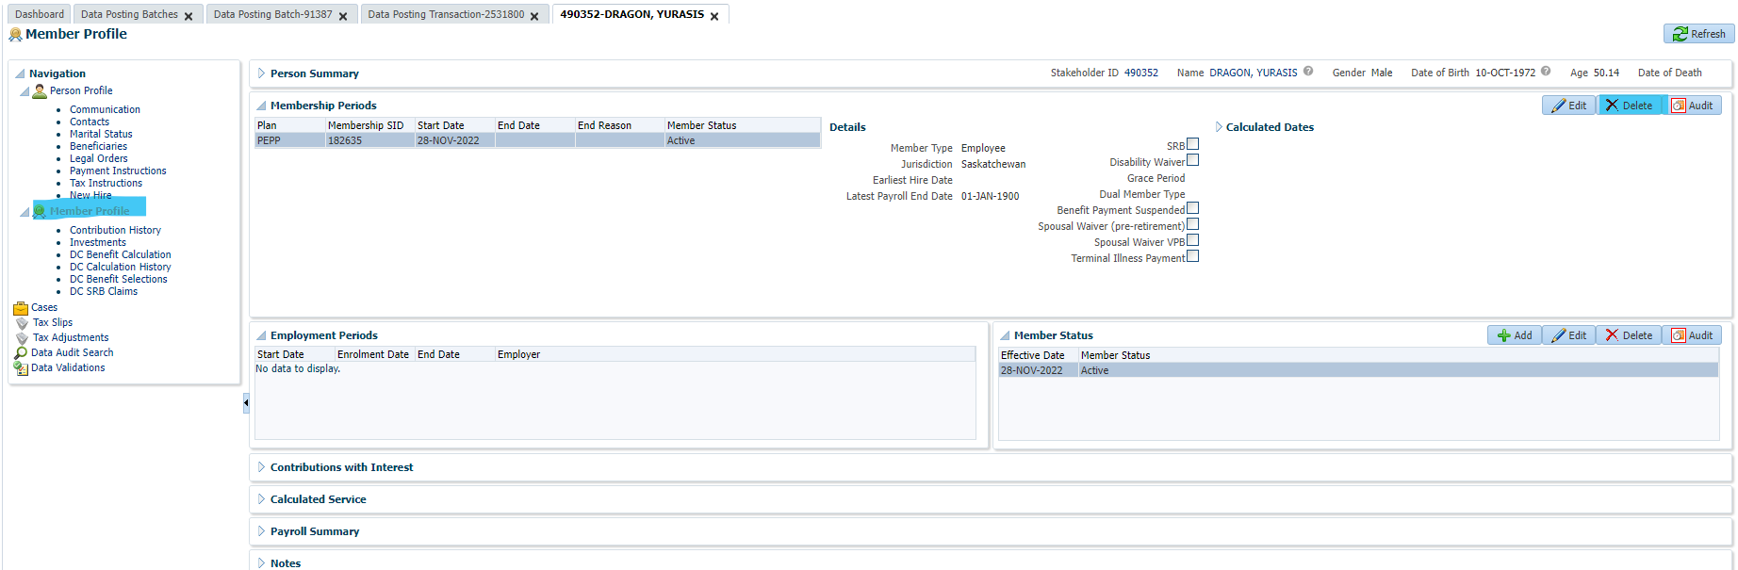

Member Profile and Investment account are now gone:

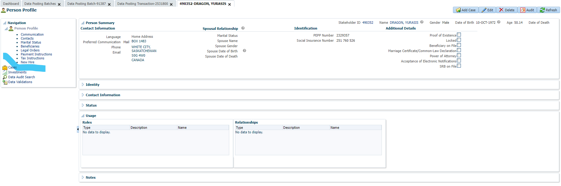

Go to Person Profile and click Delete:

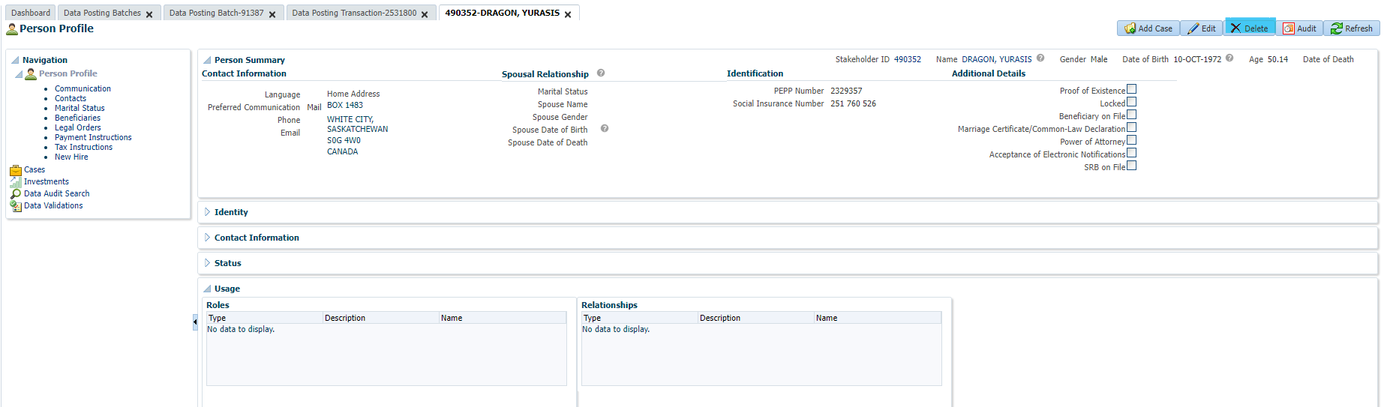

Unable to delete (but that is not required by Business):

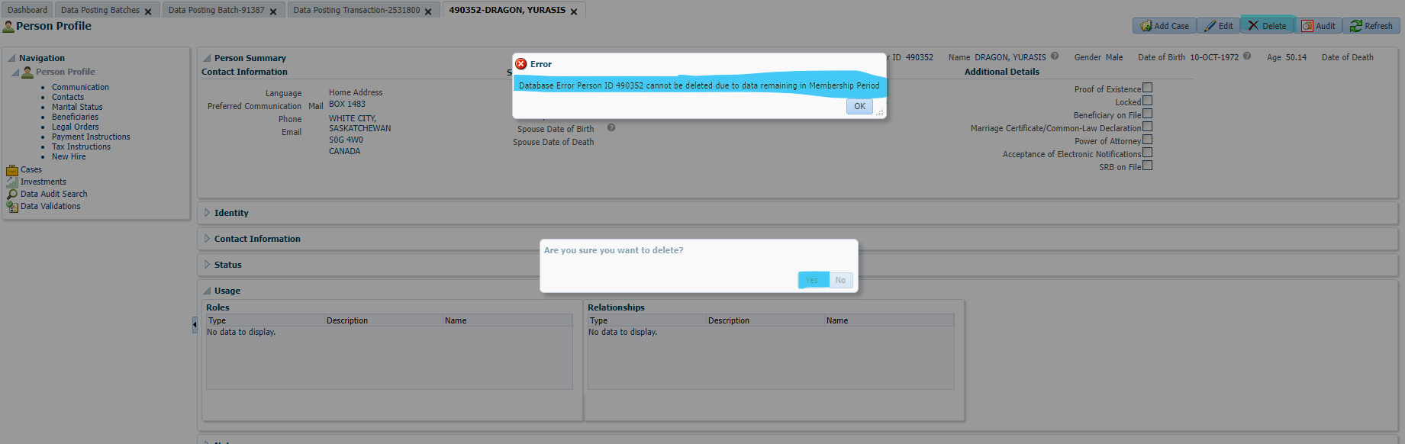

To confirm they are no longer a member, search SIN in member search, it shouldn’t bring up a result:

